|  |  |
| --- | --- |
| Date | 12 May 2023 |
| Team ID | NM2023TMID01052 |
| Project Name | Project- AI Enabled Car Parking using Open CV |
| Maximum Mark | 4 Marks |

**DATAFLOW DIAGRAM**

|  |  |  |  |
| --- | --- | --- | --- |
| **User type** | **User story number** | **User story/task** | **Team member** |
| **DRIVER** | USN-1 | As a driver, I am able to find a parking spot quickly and easily using an AI-enabled car parking system so that I can save time and reduce frustratio**n** | **Shangeetha.L** |
| **USER** | USN-2 | As a car park user, AI-enabled car parking system is ableto provide me with real-time information on available parking spots and their locations using OpenCV | **Devika.R** |
| **OWNER** | USN-3 | As a car park owner, I am able to identify parking violations automatically using OpenCV, such as parking in a disabled spot, so that I can enforce parking regulations and maintain safety | **Dharshini.S** |
| **MANAGER** | USN-4 | As a car park manager, I am able to detect the number of available parking spots in real-time using OpenCV so that I can manage the parking lot more efficiently | **Dharshini.v** |

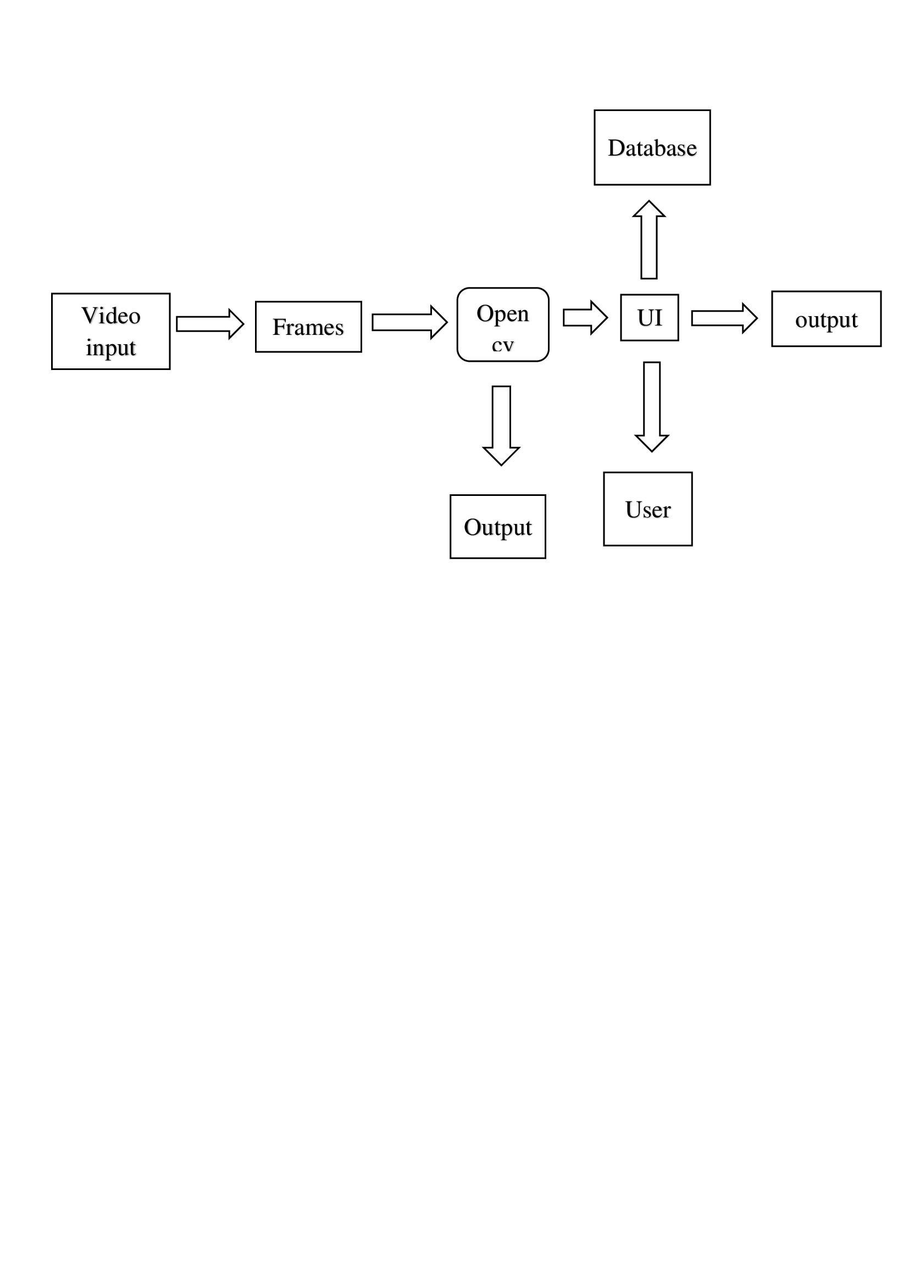**USER STORIES**